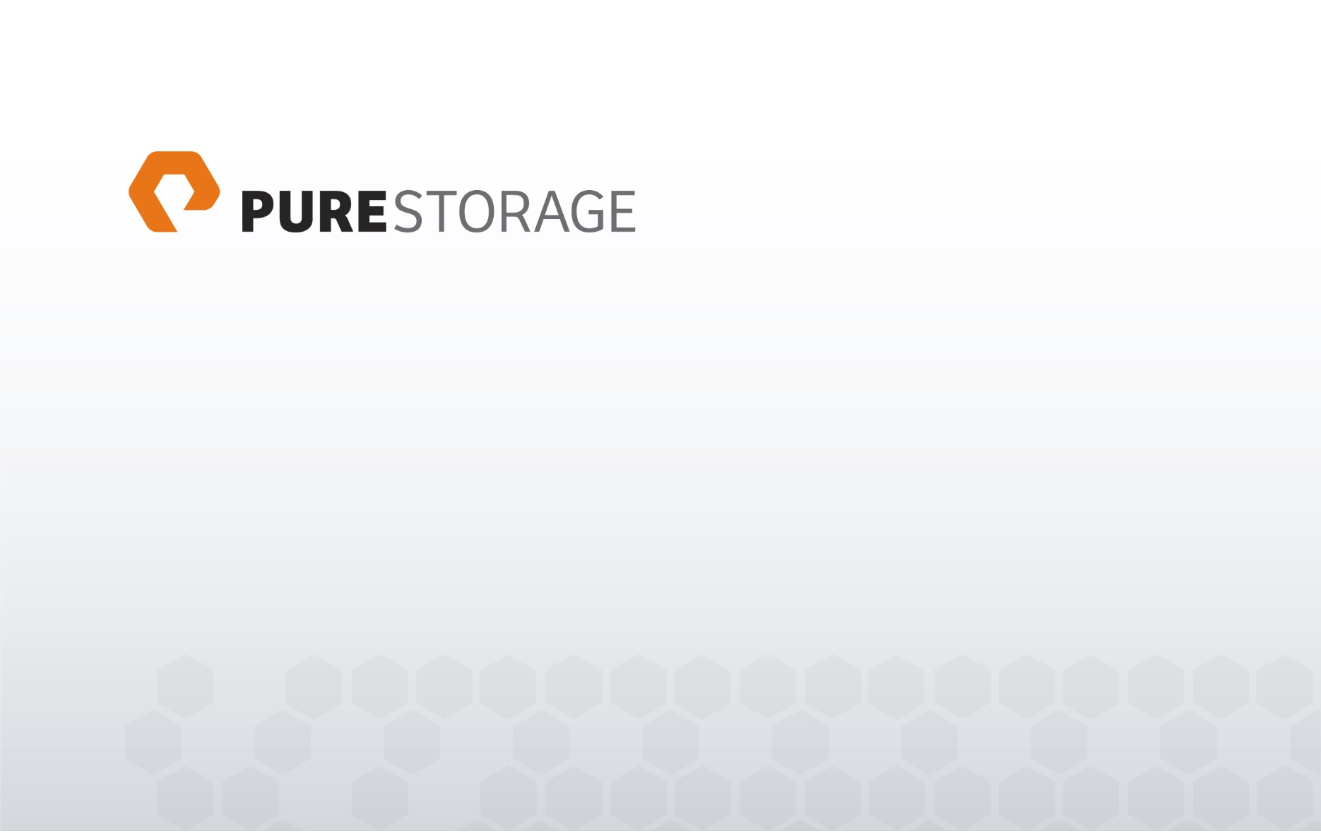VENE Snap Automation Tool – ActiveCluster 3rd Site Replication

*User manual*

Table of contents

1. Introduction 3

2. System requirements 3

3. Script directory 4

3.1. config.xml 4

3.2. encryptAES.ps1 5

3.2.1. Parameter 5

3.3. functions.psm1 5

3.4. podbackup.ps1 5

3.4.1. Parameter 5

4. Installation 6

5. Operation 8

6. Logic 9

6.1. Main process 9

6.2. FlashArray prechecking 10

6.3. Cloning the volumes and prepare to transfer 11

6.4. Cleaning up 12

6.5. Target FlashArray - Volume create and apply retention 12

7. Examples 13

7.1. encryptAES.ps1 13

7.2. podbackup.ps1 15

# Introduction

The script was developed to automate the VM backup mechanism on ActiveCluster.

During the script run, VM snapshots will be created. After successfully VM snapshot creation a POD copy will be created. The volumes of POD copy are added in an asynchronous Protection Group and the Protection Group is replicated in the backup site.

# System requirements

* Windows 8 Pro, Enterprise 64 bit
* Windows 8.1 Pro, Enterprise 64 bit
* Windows 10 Pro, Enterprise 64 bit
* Windows Server 2012
* Windows Server 2012 R2
* Windows Server 2016
* Windows Management Framework 3.0
* Windows Management Framework 4.0
* Windows Management Framework 5.0
* Windows Management Framework 5.1
* .NET Framework 4.5
* .NET Framework 4.6
* .NET Framework 4.7
* VMware vSphere PowerCLI 6.0
* VMware vSphere PowerCLI 6.3
* VMware PowerCLI 6.5
* PureStoragePowerShellSDK 1.7.4.0

# Script directory

Length Name

------ ----

704 config.xml

1449 encryptAES.ps1

3918 functions.psm1

23236 podbackup.ps1

## config.xml

The configuration file is an XML file. All fields must be filled! There are 3 sections:

**<general>**

<KeyFile>AES.key</KeyFile> - The file is used to encrypt and decrypt the password. The file does not exist before the first use. The encryptAES.ps1 also generates the keyfile.

**<FlashArray>**

<SourceArray></SourceArray> - A member of ActiveCluster. Domain name or IP address.

<TargetArray></TargetArray> - The destination array. Domain name or IP address

<User>pureuser</User> - Username. This element is available in the section FlashArray and vmware as well.

<SecureFile>SecFileFA.txt</SecureFile> - This file contains the encrypted password for the user. This element is available in the section FlashArray and vmware as well.

<POD></POD> - Name of the POD that replicates to the DR system (2nd array).

<WaitTransferSeconds>60</WaitTransferSeconds> - During replication it takes so

many seconds to wait until the next query.

<TargetPrefix>COPY</TargetPrefix> - The volume names will begin with the following prefix at the backup site. **Attention**! The prefix is ​​needed to manage the volume retention time!

<TargetRetention>28</TargetRetention> - Number of retained volume copies on the DR site.

**<vmware>**

<vCenter></vCenter> - The vCenter domain name or IP address.

<User></User> - Username. This element is available in the section FlashArray and vmware as well.

<SecureFile>SecFileVC.txt</SecureFile> - This file contains the encrypted password for the user. This element is available in the section FlashArray and vmware as well.

**<Datastores>** - Under the tag is it possible to define the datastores. Several datastores are also possible.

<DatastoreName></DatastoreName> - Name of datastore.

<WaitTaskSeconds>10</WaitTaskSeconds> - How many second to wait before verify snapshot creation.

## encryptAES.ps1

This file is used to create the encrypted password file and key file. This is necessary at installation, or at password change.

### Parameter

-KeyFile <File name> 🡪 Optional if the default value is appropriate. Default value: AES.key

-NewKeyRequired 🡪 Optional. Switch parameter. If specified, the keyfile will be regenerated. **Attention! When newly creating the key file, all password files must be regenerated!**

-NewSecurePasswordFile <File name> 🡪 Optional if the default value is appropriate. Default value: SecFileFA.txt

-Password <Password> 🡪 Mandatory

## functions.psm1

This contains the functions. The file must exist in the script directory!

## podbackup.ps1

Main script. It is carried out the complete backup process.

### Parameter

-Config <File name> 🡪 Optional if the default value is appropriate. Default value: config.xml

-ApplyRetention 🡪 Optional. Switch parameter. If this is specified then the copies will be kept and activated.

-OverwriteStandaloneTarget 🡪 Optional. Switch parameter. If this is specified then the standalone volume for volumes copied will be overwritten.

# Installation

The complete script is provided in a ZIP file. In the first step, please check the ZIP file using validation file sha1. Extract the compensated file in the destination folder.

The configuration file must be filled out carefully! (config.xml)

You can use the script encryptAES.ps1 to create the key and password files.

You can now add the script with the specific parameters to the Windows Task Scheduler.

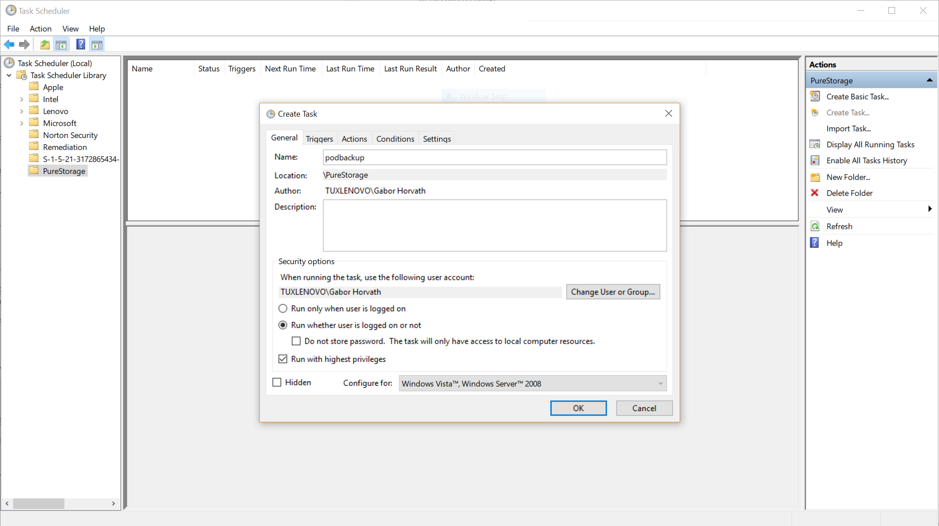

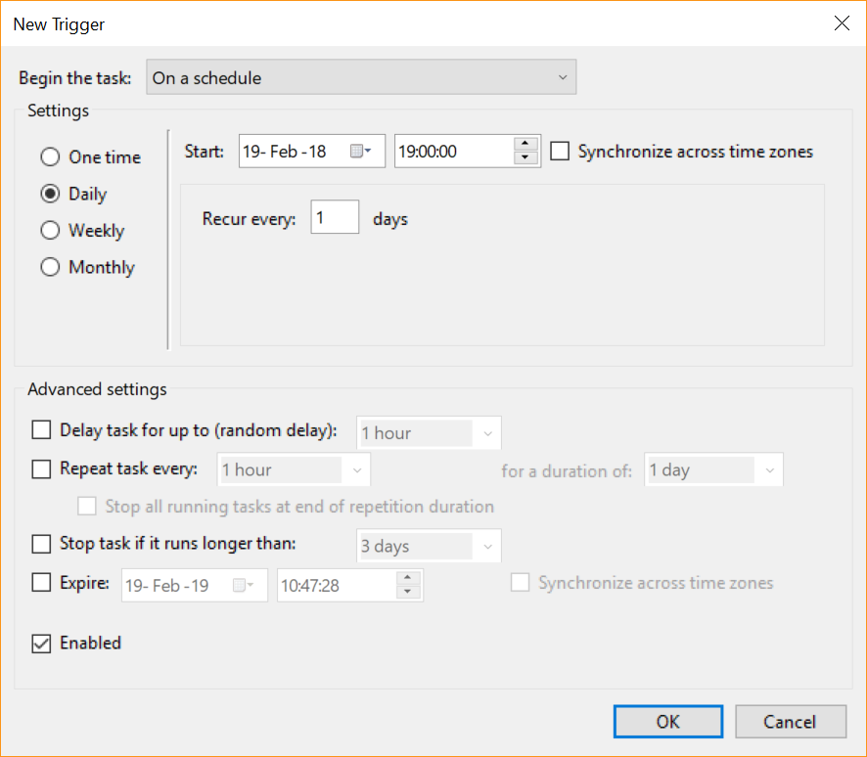

powershell.exe

-Command ". '.\podbackup.ps1' -ApplyRetention; exit $LASTEXITCODE"

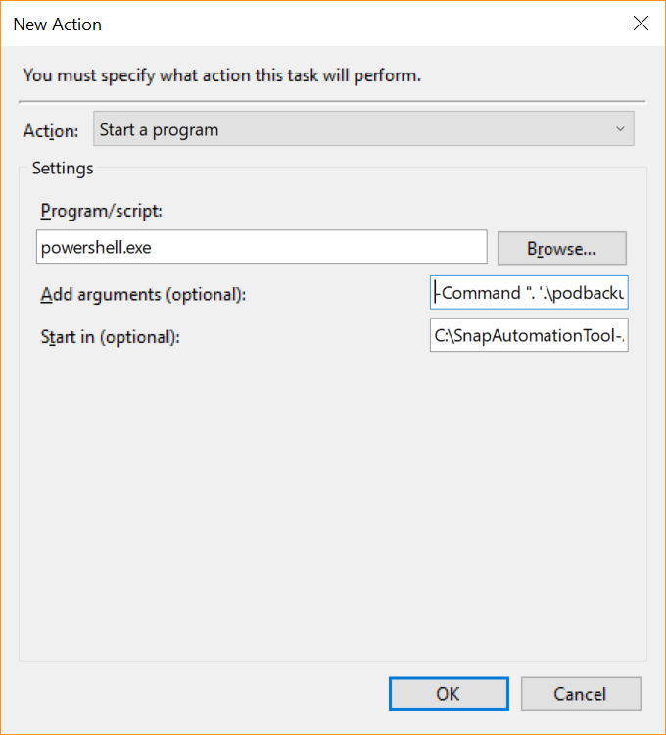

# Operation

The task scheduler calls the script. The script generates a LOG file at every run (runlog_yyyyMMdd_HHmmss.log). The LOG file contains very detailed information (DEBUG).

Return code table:

|  |  |  |
| --- | --- | --- |
| **Return code** | **Message** | **Comment** |
| 0 | - | No message. The script finished without failure. |
| 26 | The POD '<POD>' is not healthy! Please repair it! |  |
| 27 | The POD is empty or doesn't exists! POD: <POD> |  |
| 28 | The clone POD doesn't exist or no volumes copied! POD: <POD>-podbackup |  |
| 33 | Transfer is processing! Try again later! |  |
| 51 | The source array isn't online! |  |
| 120 |  | General error message. It is coming from FlashArray |
| 125 | All datastores has issues! Please check the logfile '<LOGFILE>'! |  |
| 197 | The Host or HostGroup isn't defined in the config file! |  |
| 266 |  | Unsuccessful replication. It is coming from FlashArray |
| 322 | There is no target snapshot of ProtectionGroup '<SOURCE>:<POD>-async'! |  |

# Logic

## https://documents.lucidchart.com/documents/60af6c27-8bbe-4a89-911a-f14427fc28dd/pages/0_0?a=1495&x=-18&y=-41&w=1711&h=1344&store=1&accept=image%2F*&auth=LCA%201c563cdfcecb88b609fb342d5cac34f8cff9b009-ts%3D1517157794Main process

## https://documents.lucidchart.com/documents/0219777c-0f8d-40a9-88d8-a684c50c5164/pages/0_0?a=604&x=-37&y=-40&w=1254&h=1320&store=1&accept=image%2F*&auth=LCA%201c1cd207c4f3fe2fb4f59135c2a8dba62cfbe1b2-ts%3D1517156851 FlashArray prechecking

## https://documents.lucidchart.com/documents/d27eace6-c46e-41b3-8ed5-e007e6b607d9/pages/0_0?a=407&x=357&y=-42&w=517&h=1192&store=1&accept=image%2F*&auth=LCA%202b9300811a0e41b58bd13ea3d882fdea9db11b3b-ts%3D1516779504Cloning the volumes and prepare to transfer

## Cleaning up

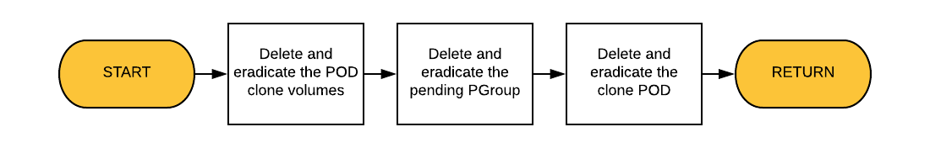

## Target FlashArray - Volume create and apply retention

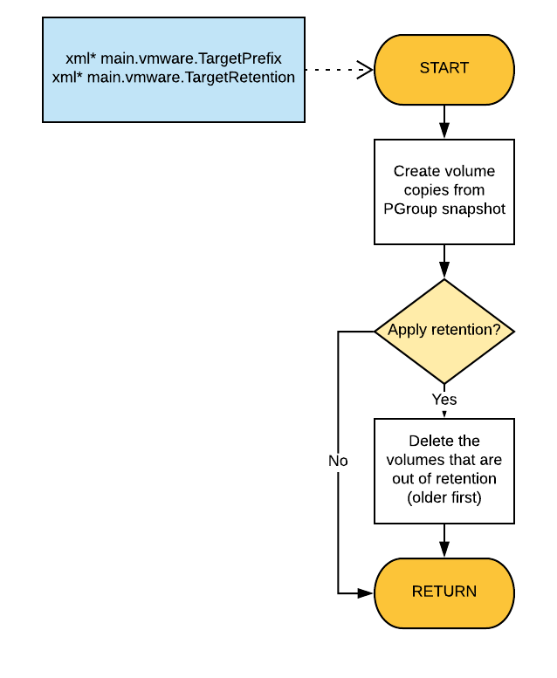

# Examples

## encryptAES.ps1

First call:

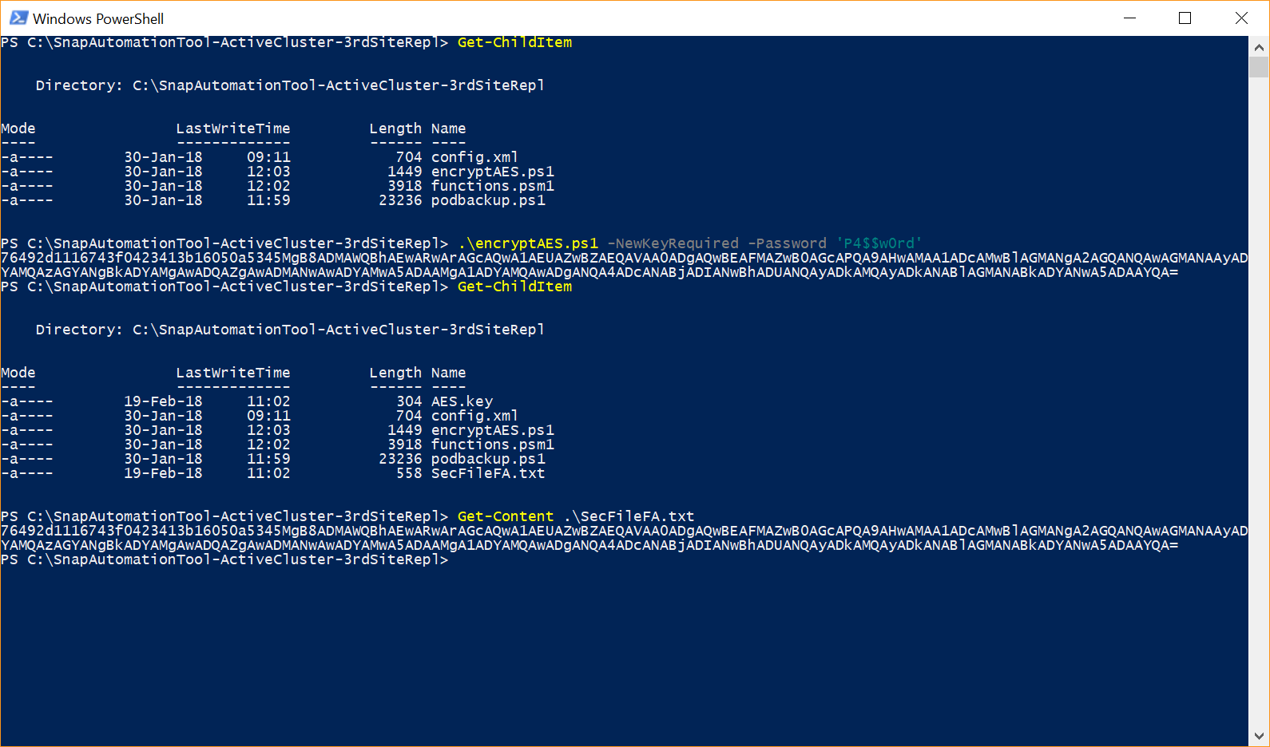

First call without parameter:

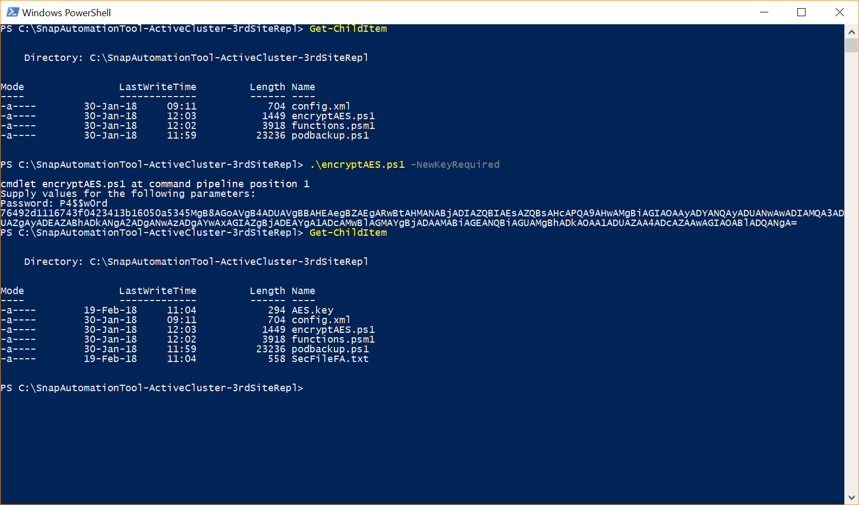

First call with another key file and another password file:

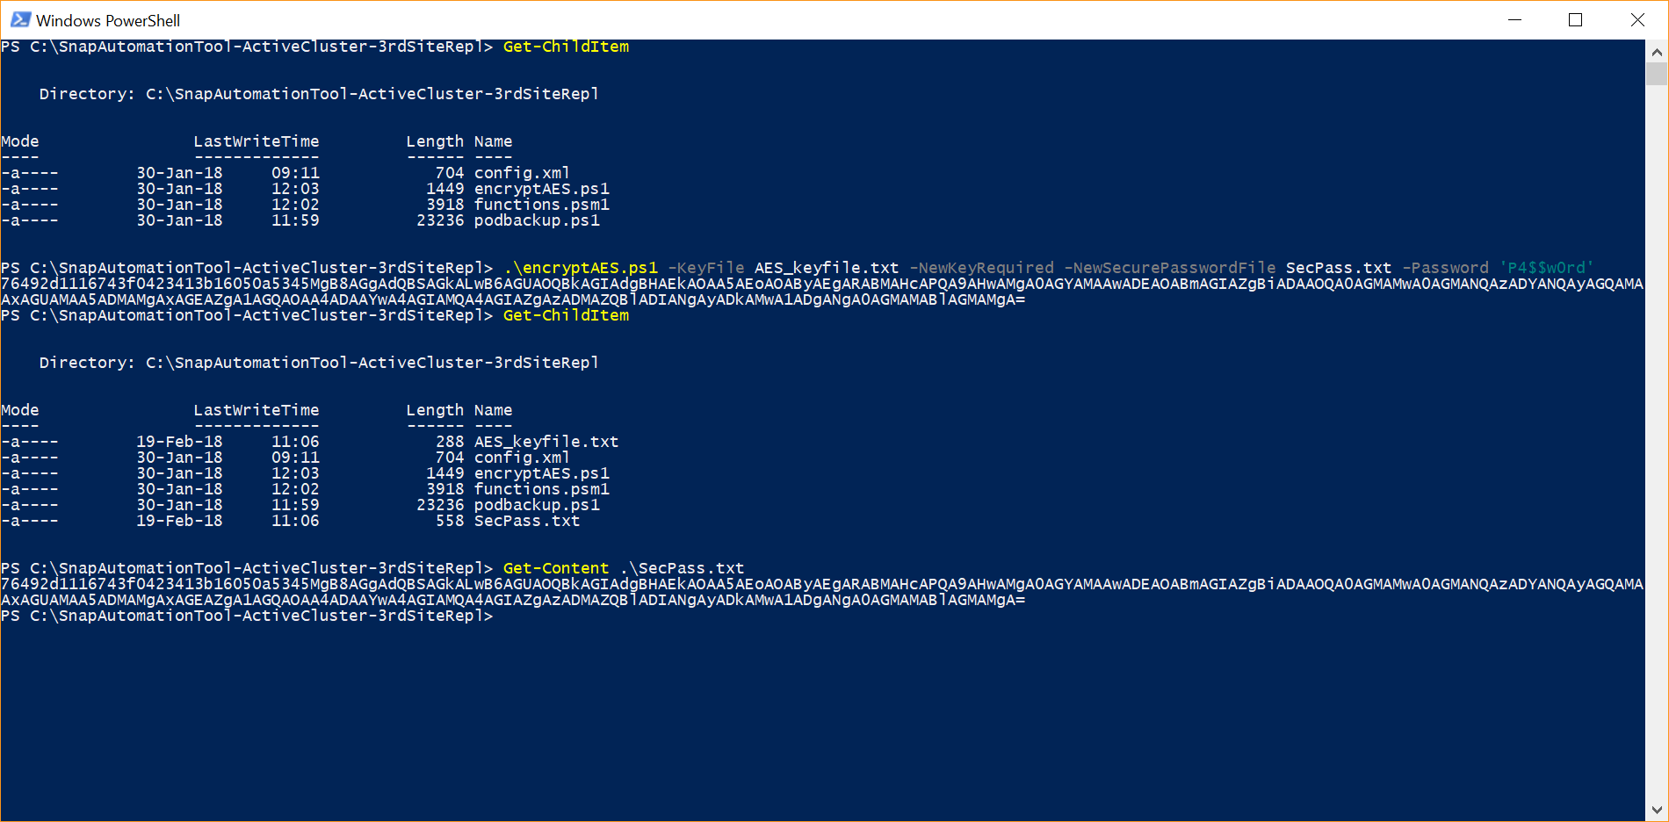

Password change:

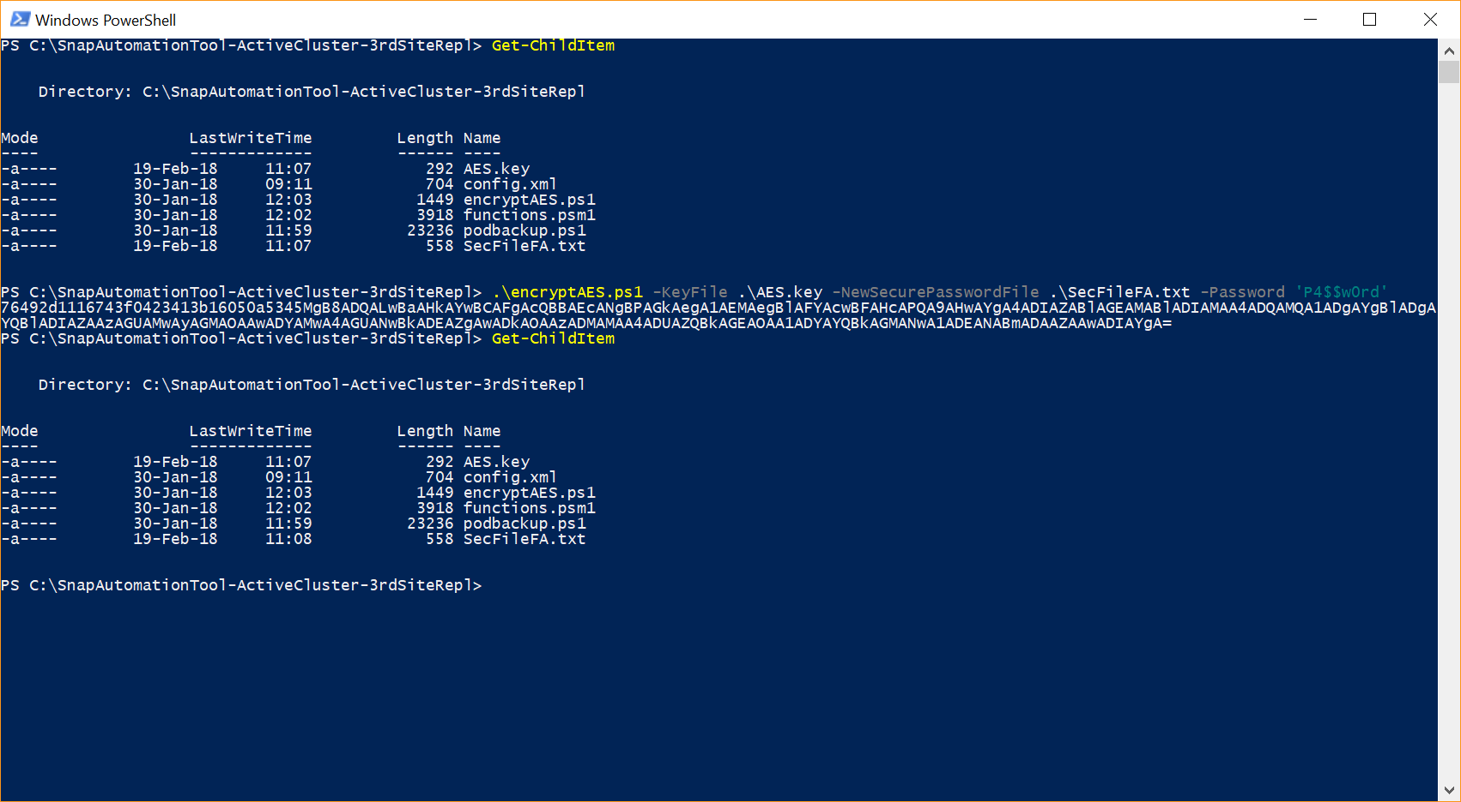

## podbackup.ps1

Call without parameter:

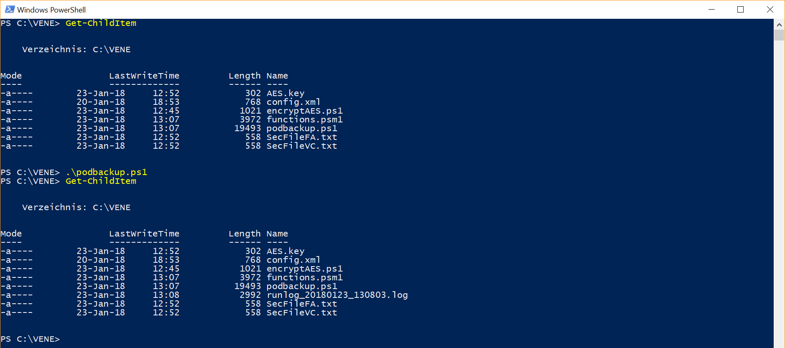

Another config file and apply retention:

